git init , touch <filename> , git status , git add <filename>,git commit -m “message”,

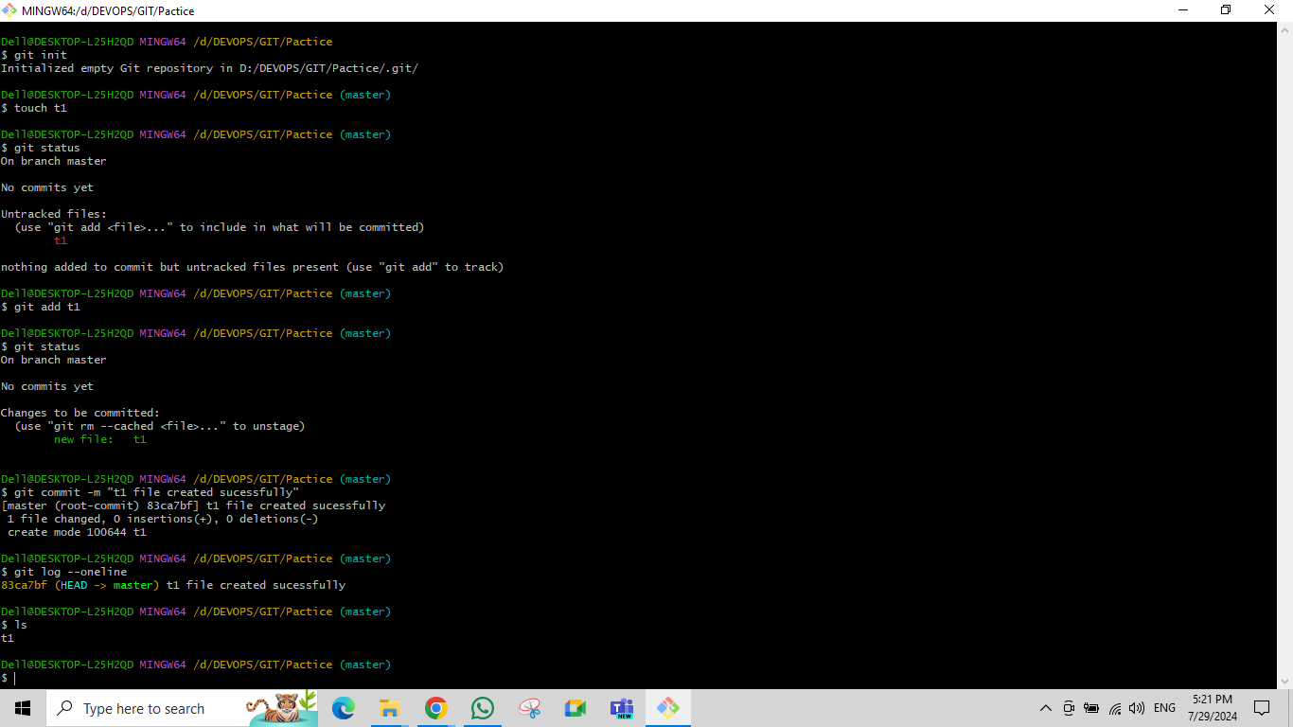git log or git log –oneline,ls

mkdir <directory name>,git branch <branch name>,git checkout <branch name>, git checkout -b <branch name >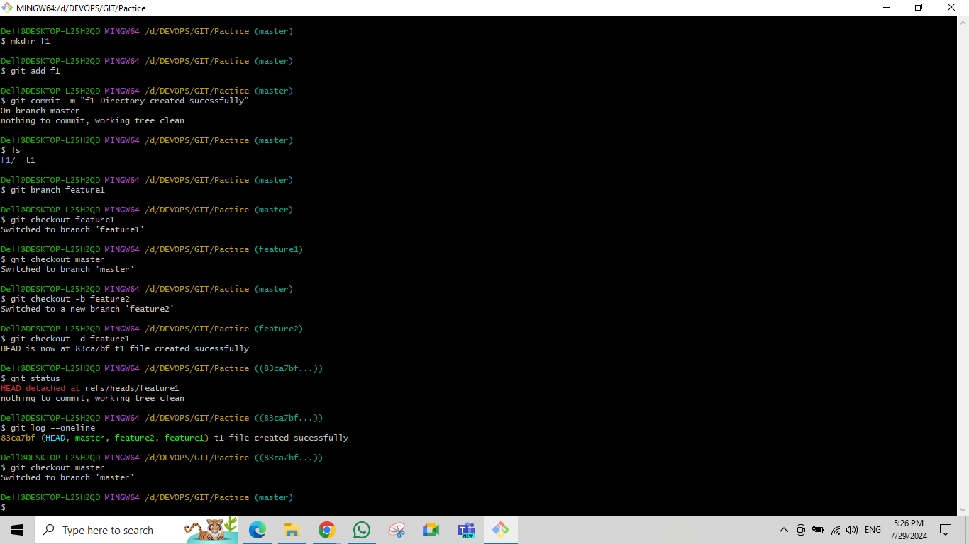

git branch -a, git merge <branch name>

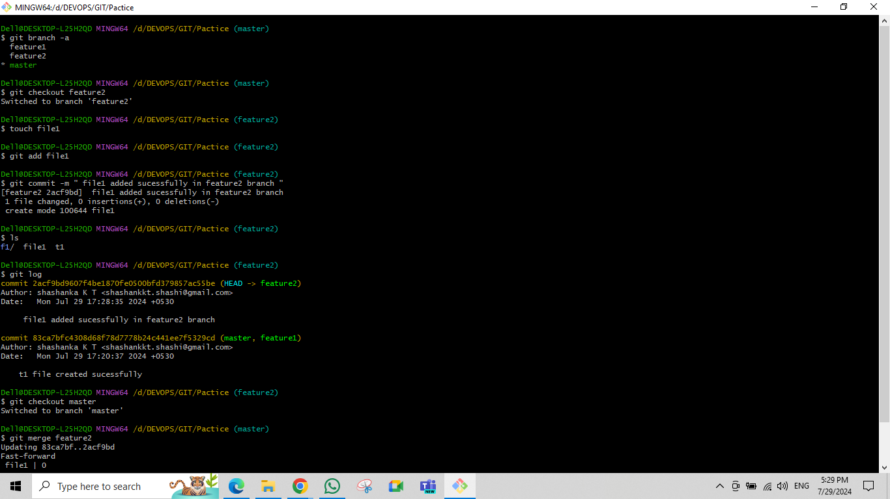

log changes after branch merged to master ,git merge <branch name >,git log

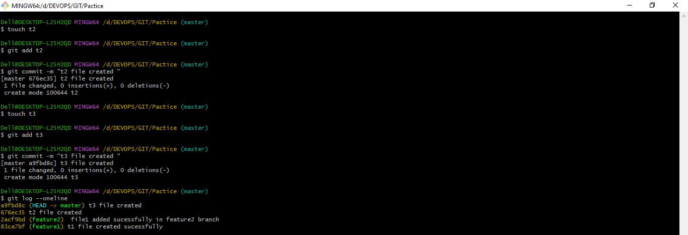

git reset –hard <commit id> or git reset –hard HEAD~1, git reset –mixed <commit id>,git status

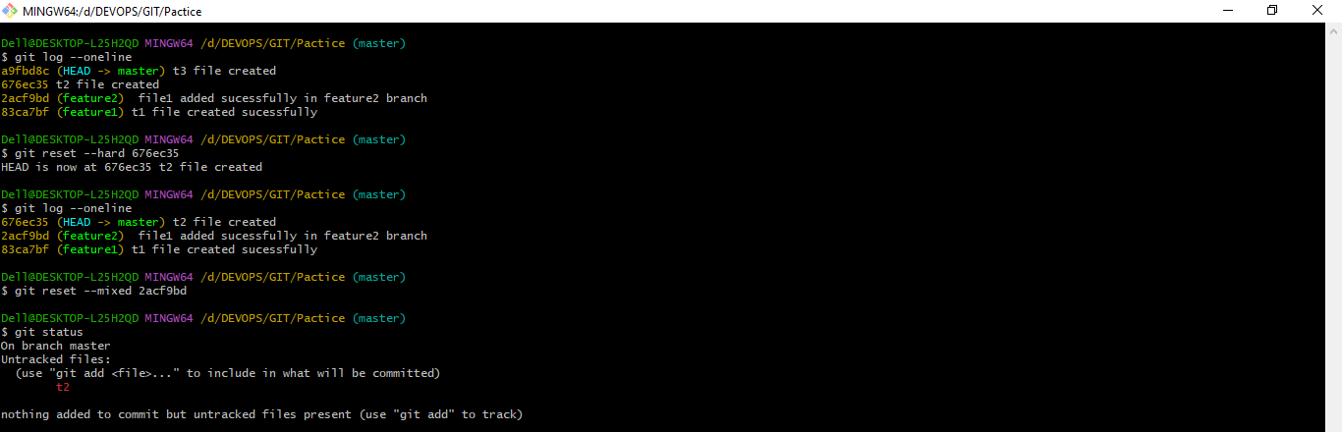

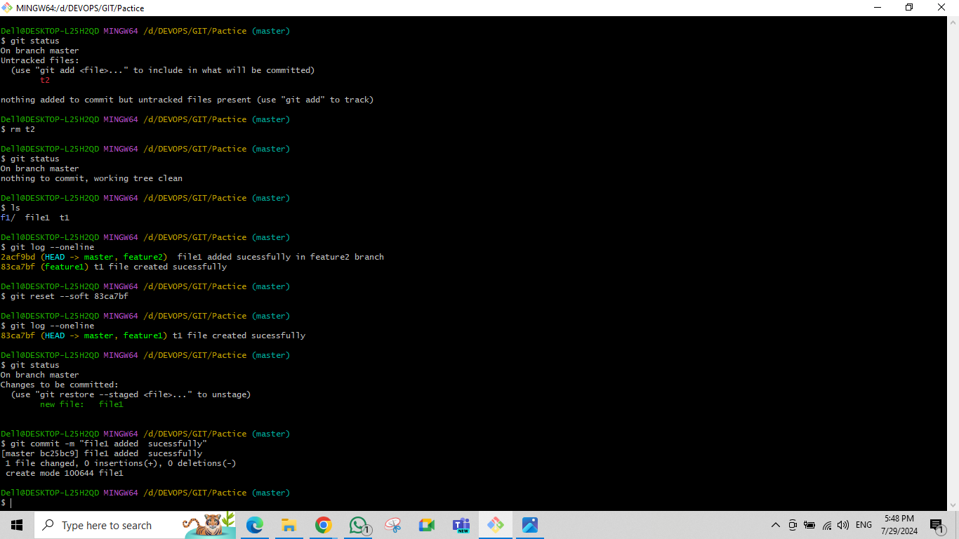rm,git reset –soft <commit id>,git status

vi <filename>,cat <filename>

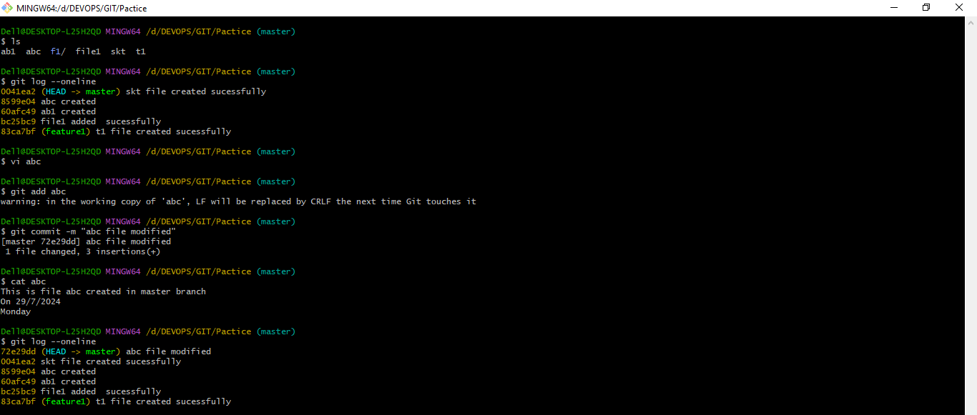

git revert <commit id>,git status,

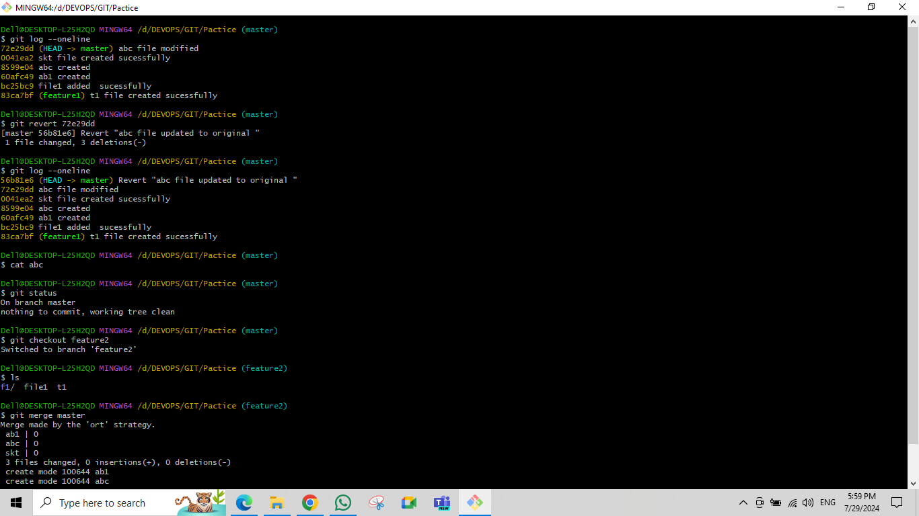

git restore <filename>

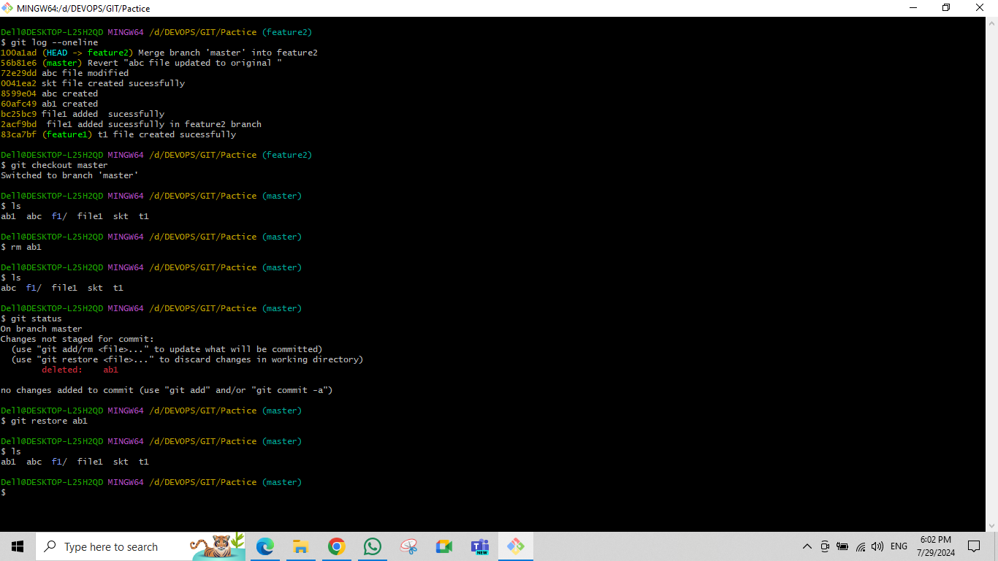

git rebase <branch name >

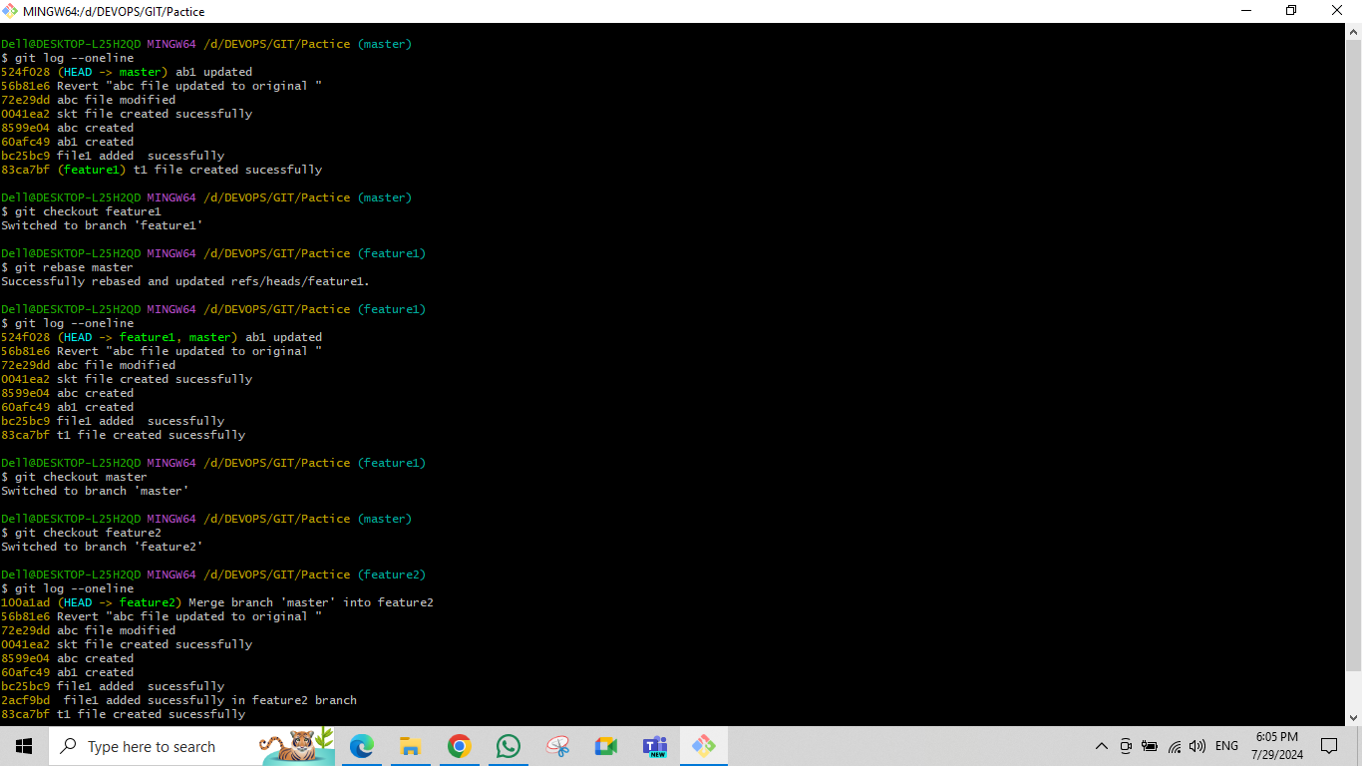

git branch –merged master, git branch –no-merged master,

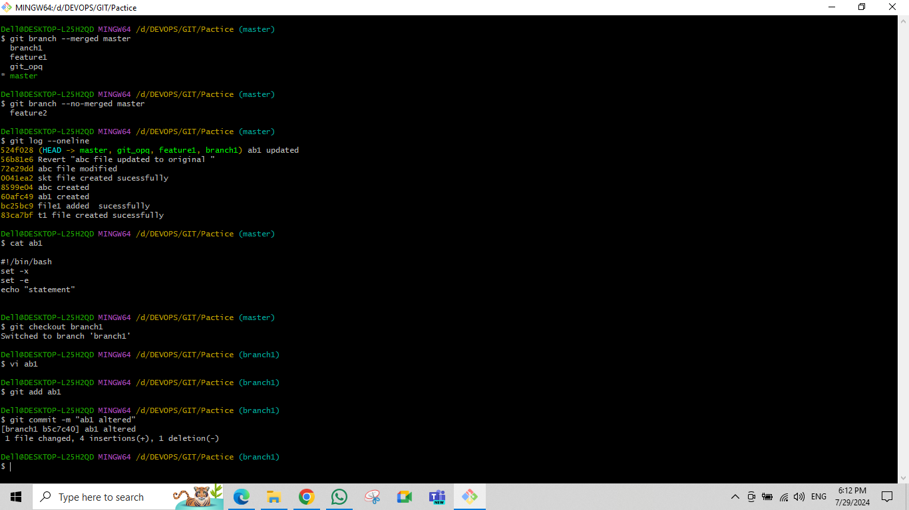

git conflict,

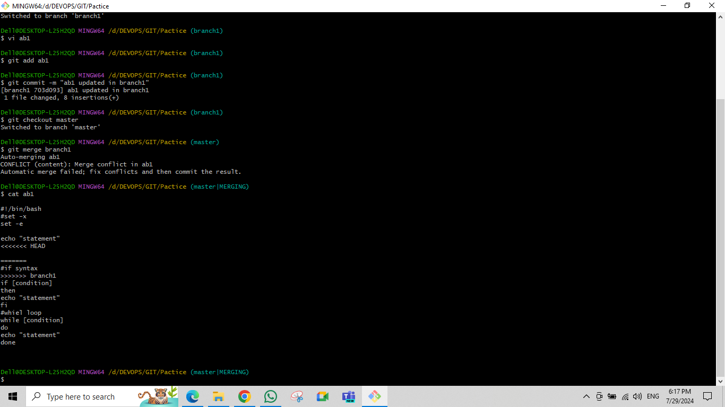

ssh-keygen -t rsa ,cat .shh/id_rsa to generate pub key,to establish password less conncetion

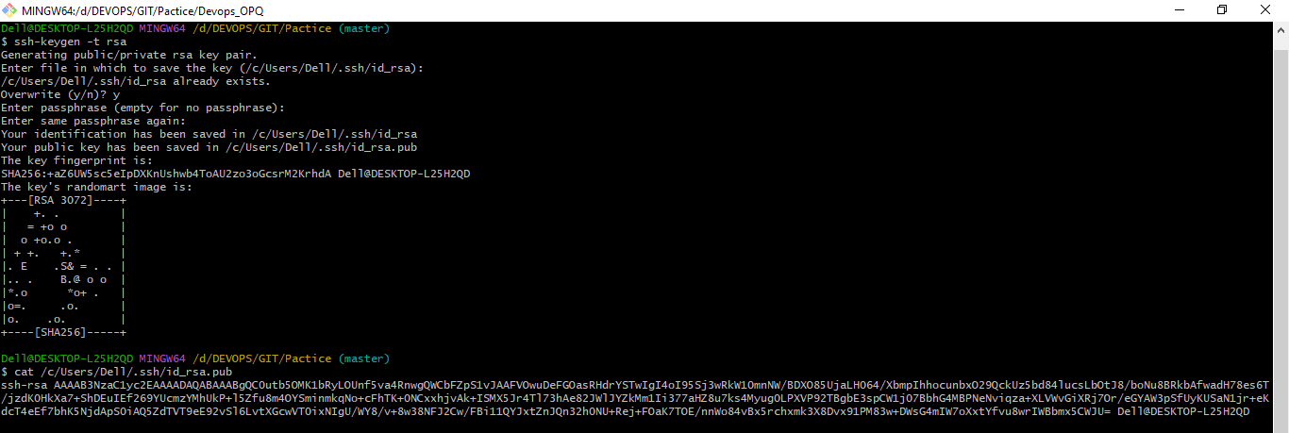

git hub ,Adding SSH key in GIT hub copied from Local repo to establish password less connection

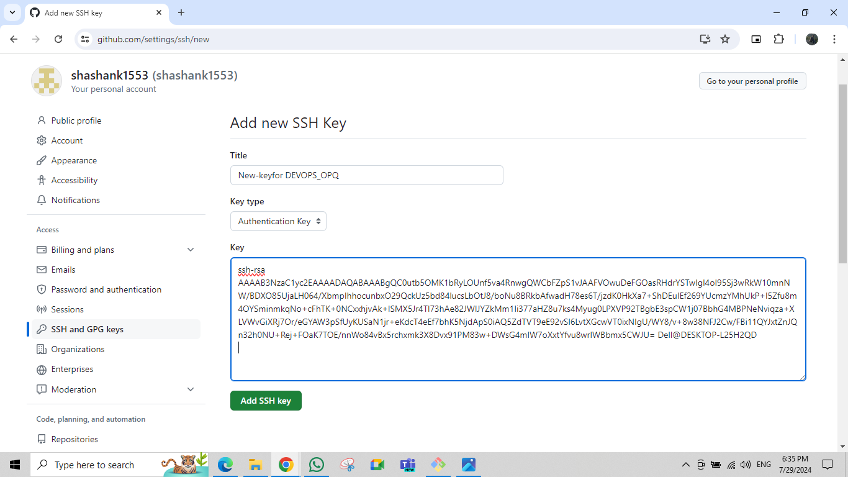

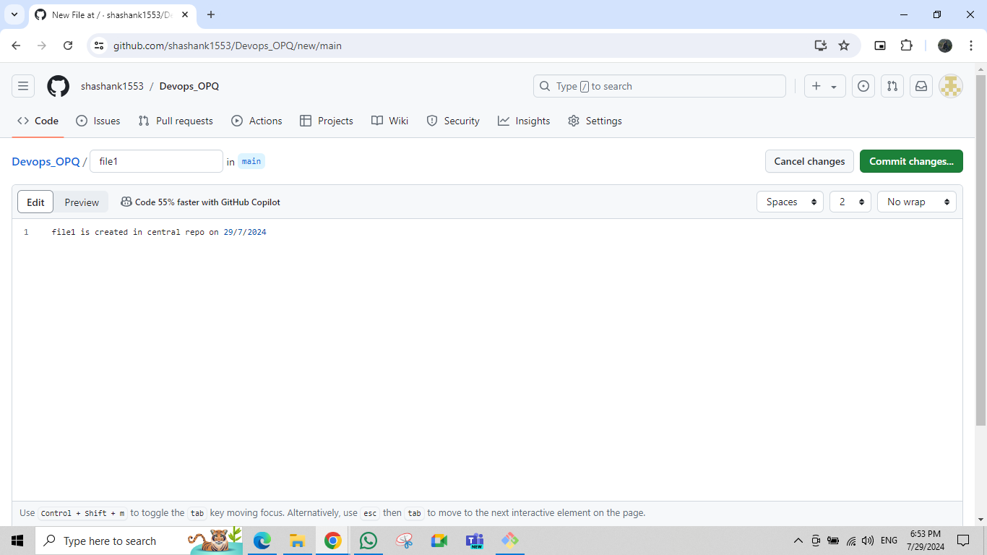git hub🡪 creating a file in Devops_OPQ repo in Central repo

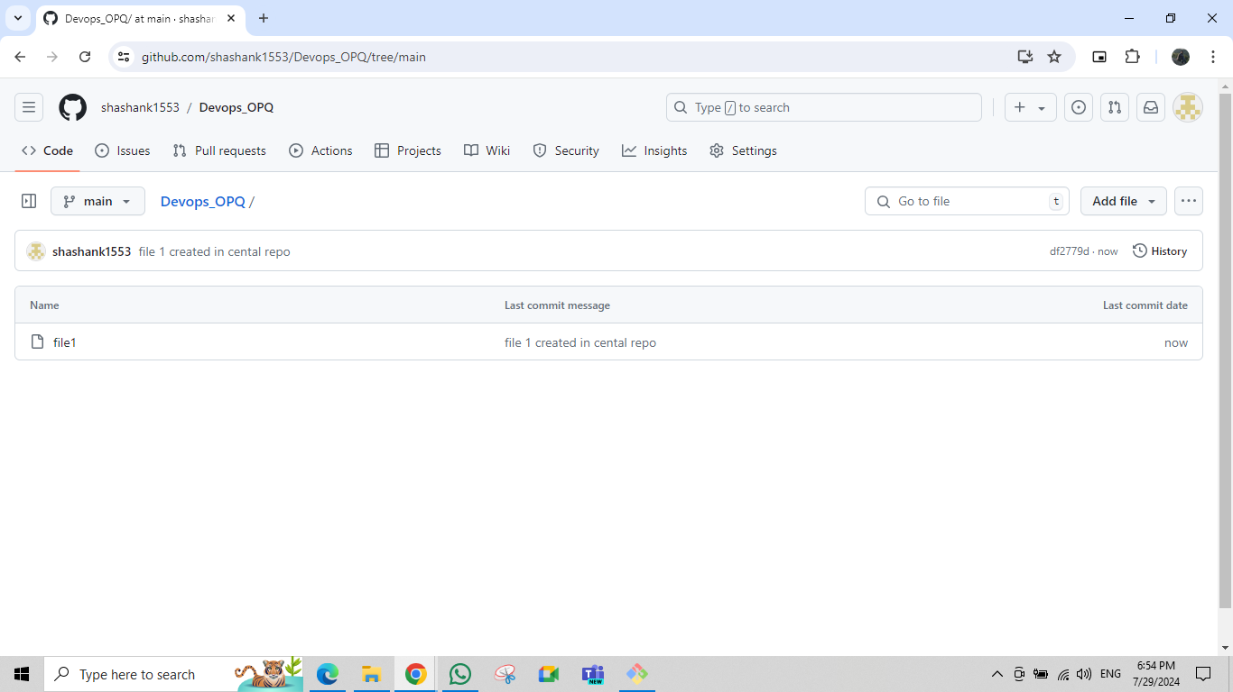git hub🡪 file created in Devops_OPQ repo with commit message

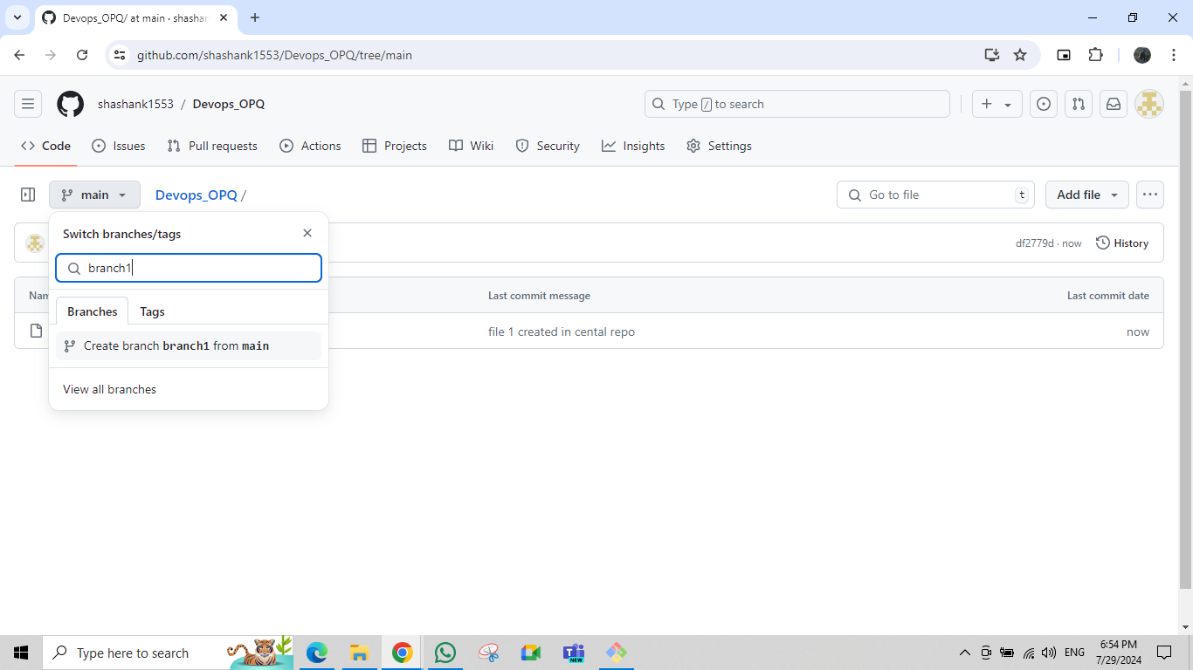git hub🡪creating branch in Devops_OPQ repo called branch1

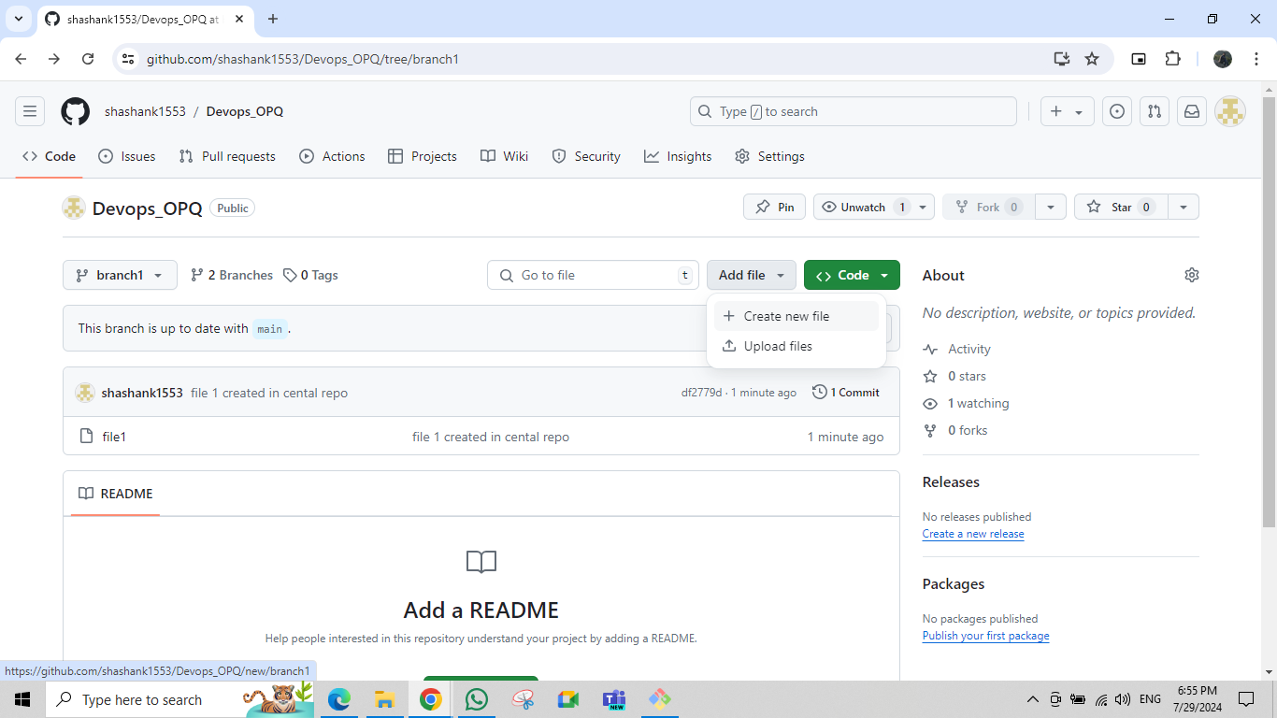git hub🡪branch1 created and Auto-merged with main (default)

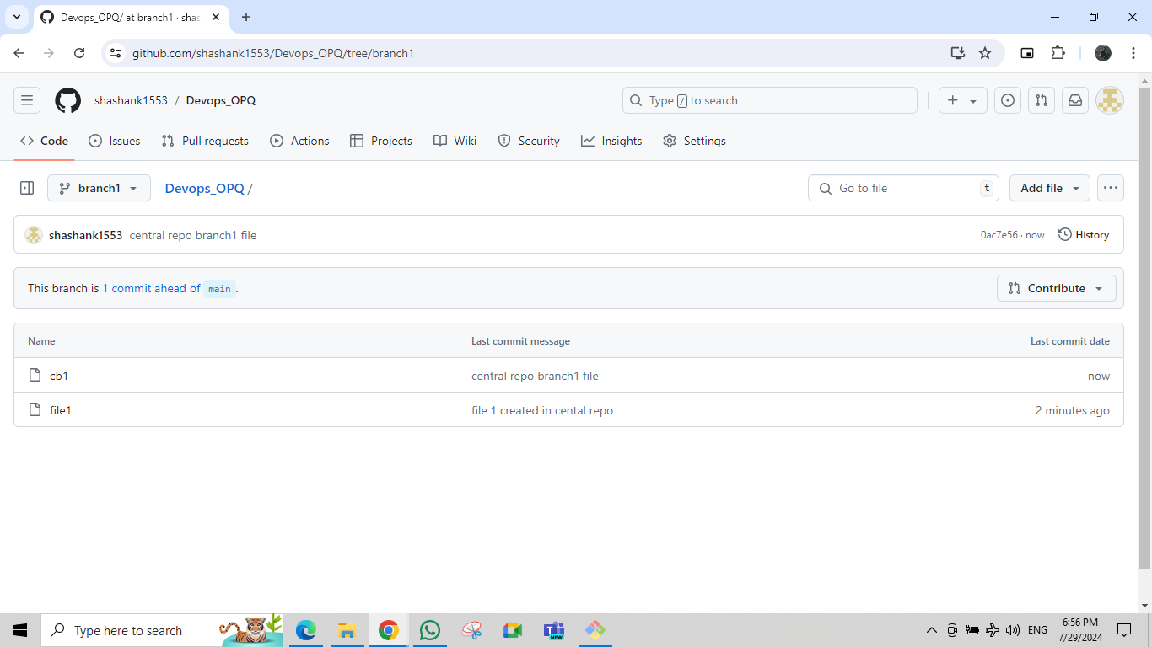github🡪cb1 file created in branch1

git hub🡪 Merge request to the main when changes made in branch1 i.e comapare &pull request

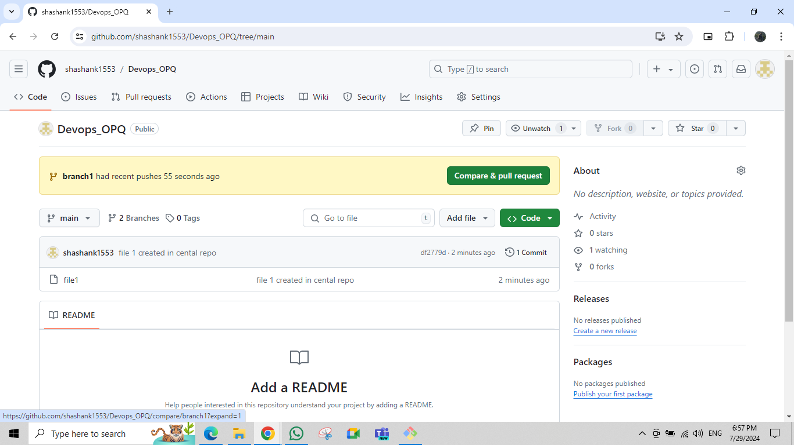

git hub🡪creating pull request

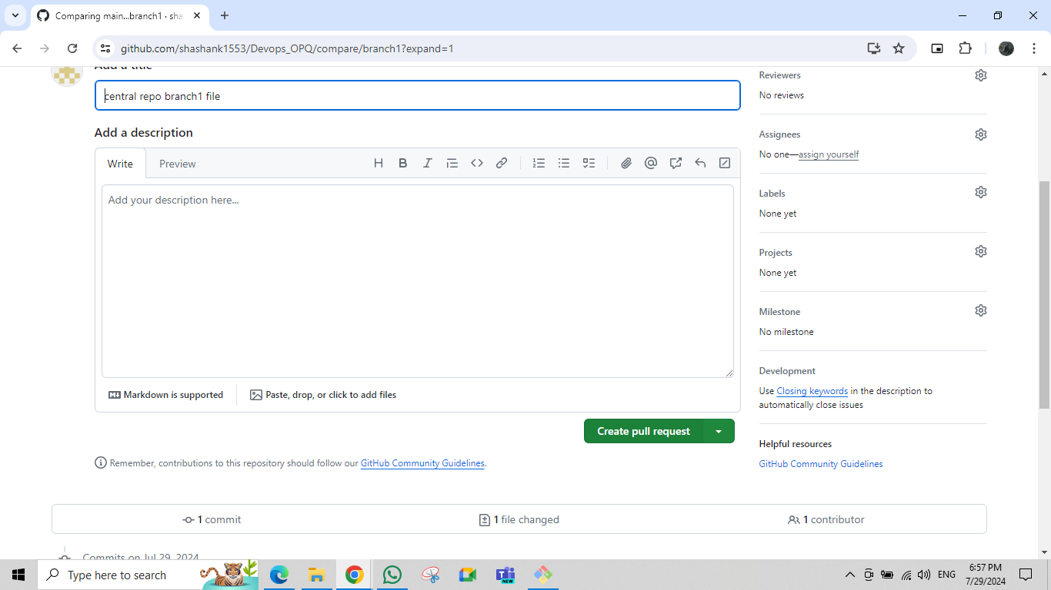

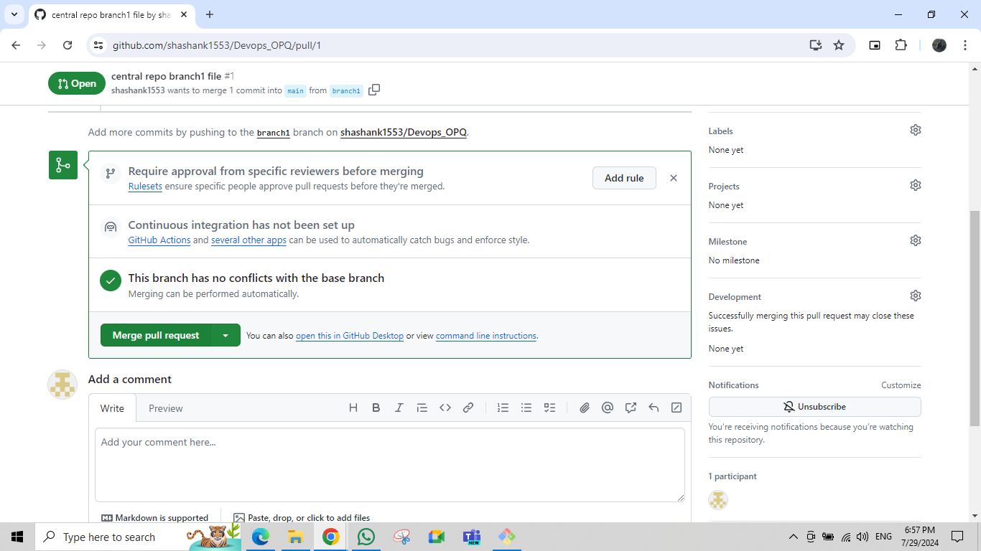git hub🡪Merge request to the Main branch

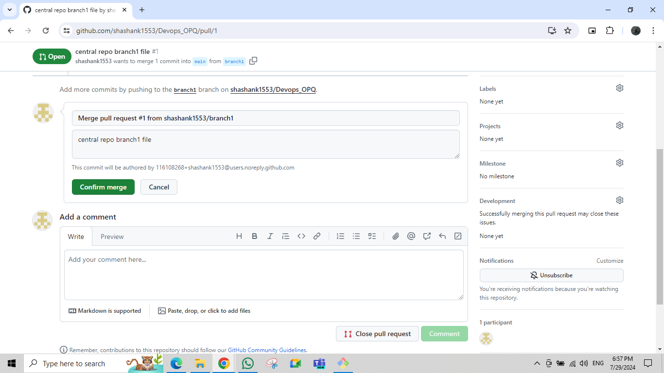github🡪 confirming merge request with new commit message

git hub🡪Files updated in Main After merged with Branch1

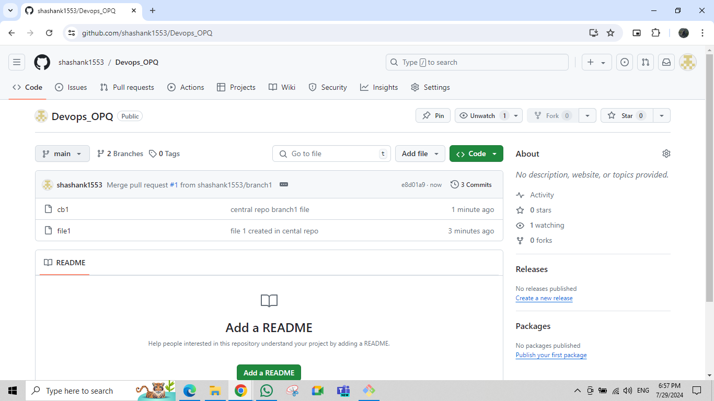

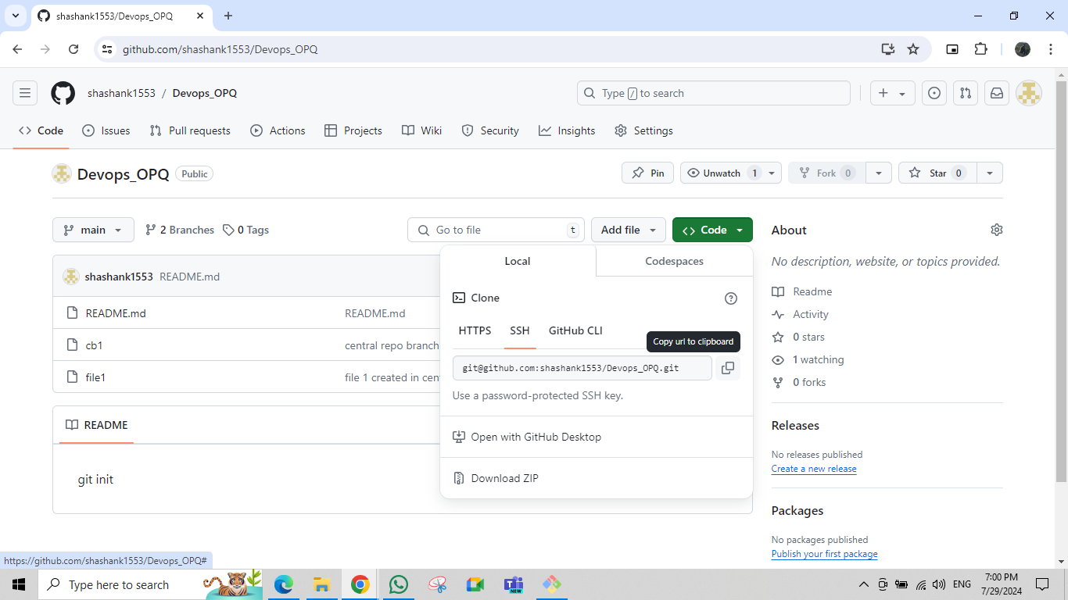git hub🡪 To Clone with Local repo copied SSH key in Devops_OPQ repo

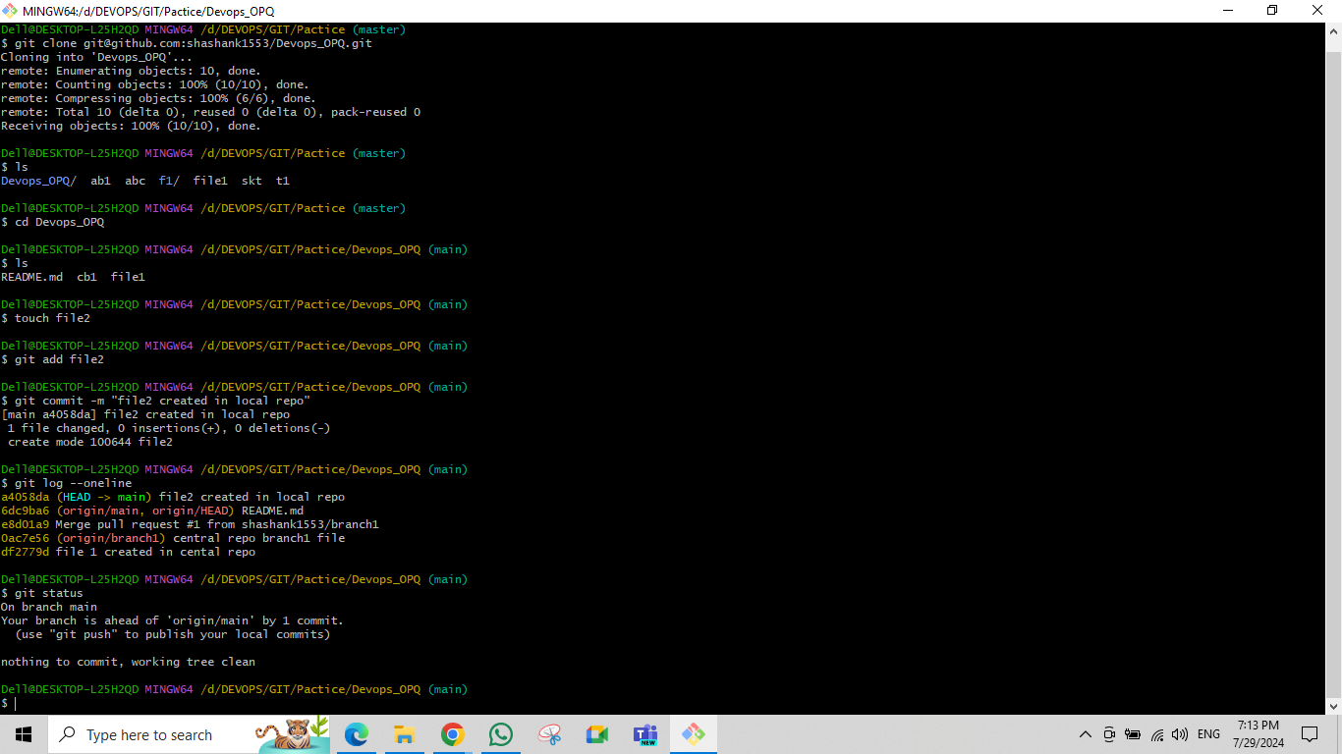git clone <SSH copied from Devops_OPQ>, ls ,git log –oneline ,git status , touch <filename>,git add <filename >,git commit -m “message ” ,creating a new file in Local repo inside Devops_OPQ (main)

git 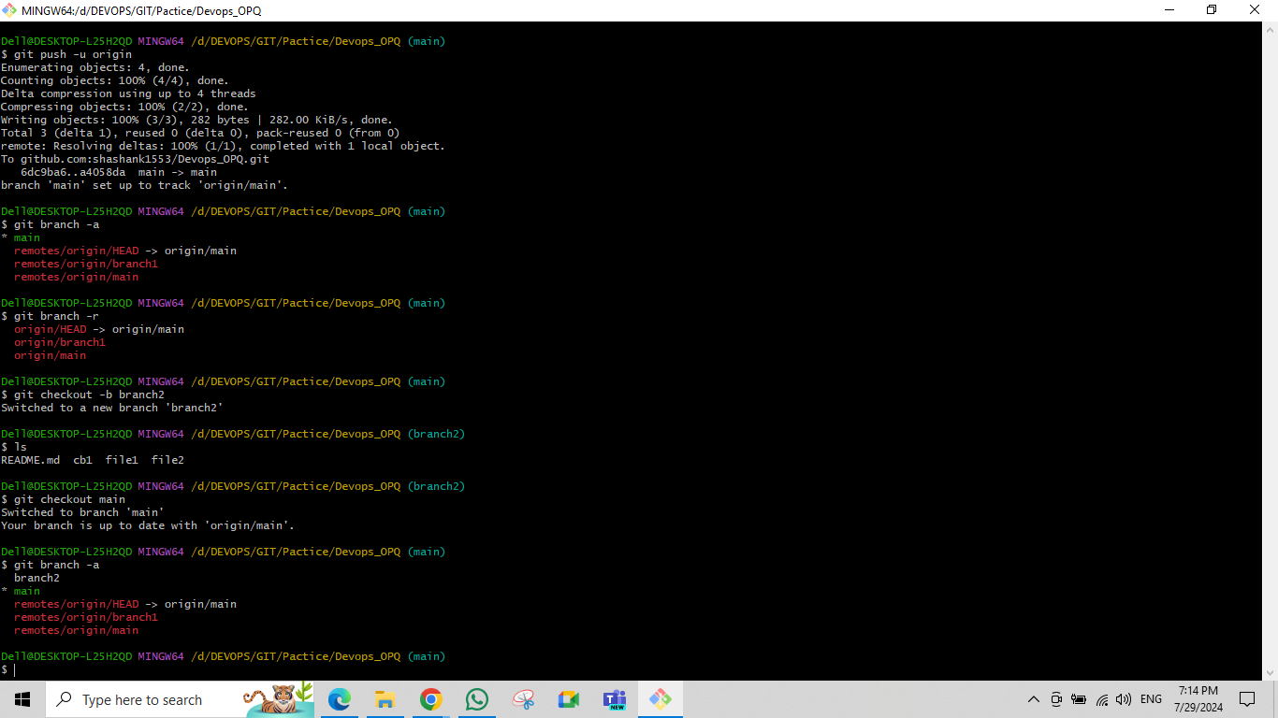push -u origin /git push,git branch -a,git branch -r,git checkout -b <branch name>

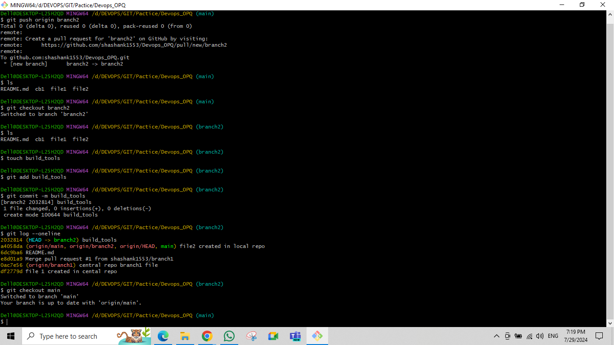git push origin <branchname > ,

git cherry-pick <commit-ID>

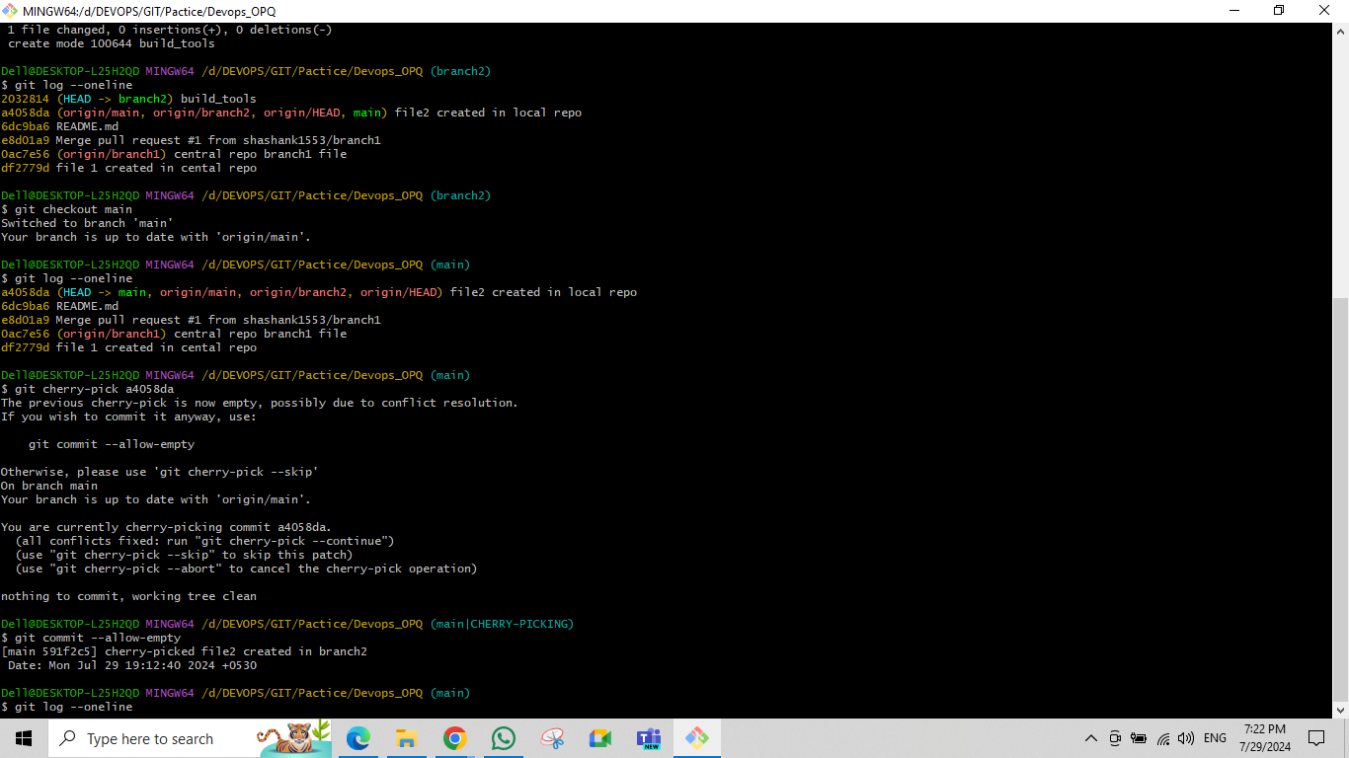

git cherry-pick <commit-ID>, git log --oneline

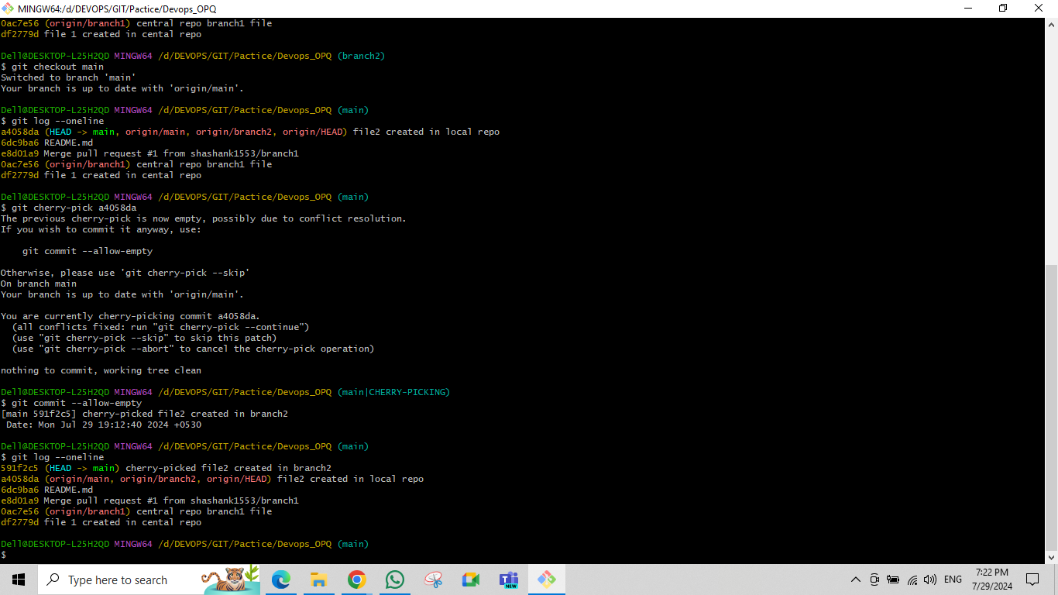

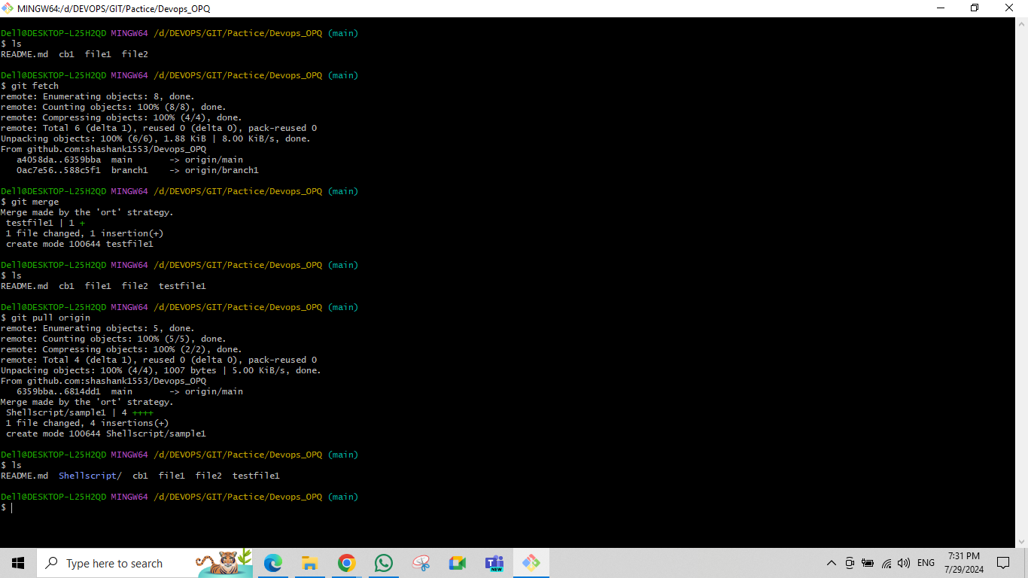git fetch, git merge, git pull origin

git hub🡪 git tags

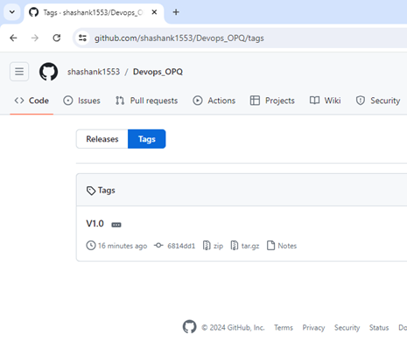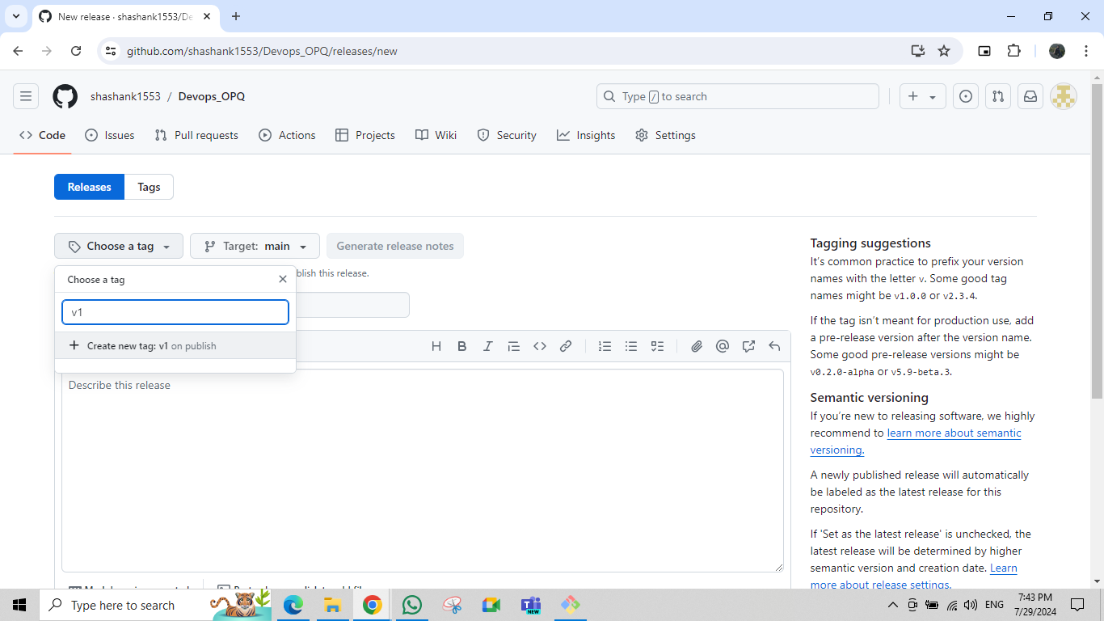creating tags tags

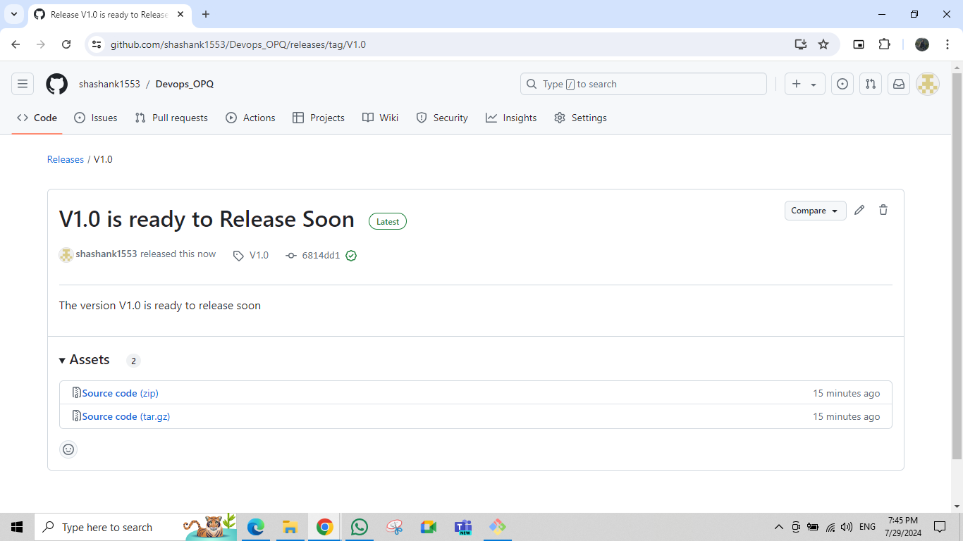git hub 🡪 git release

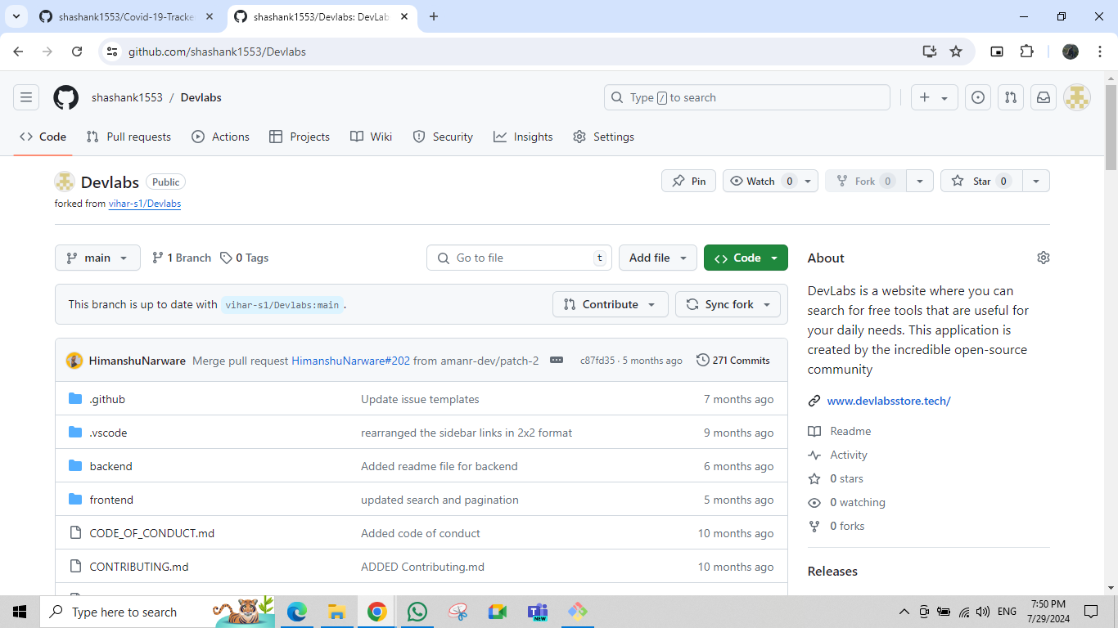git hub🡪git fork

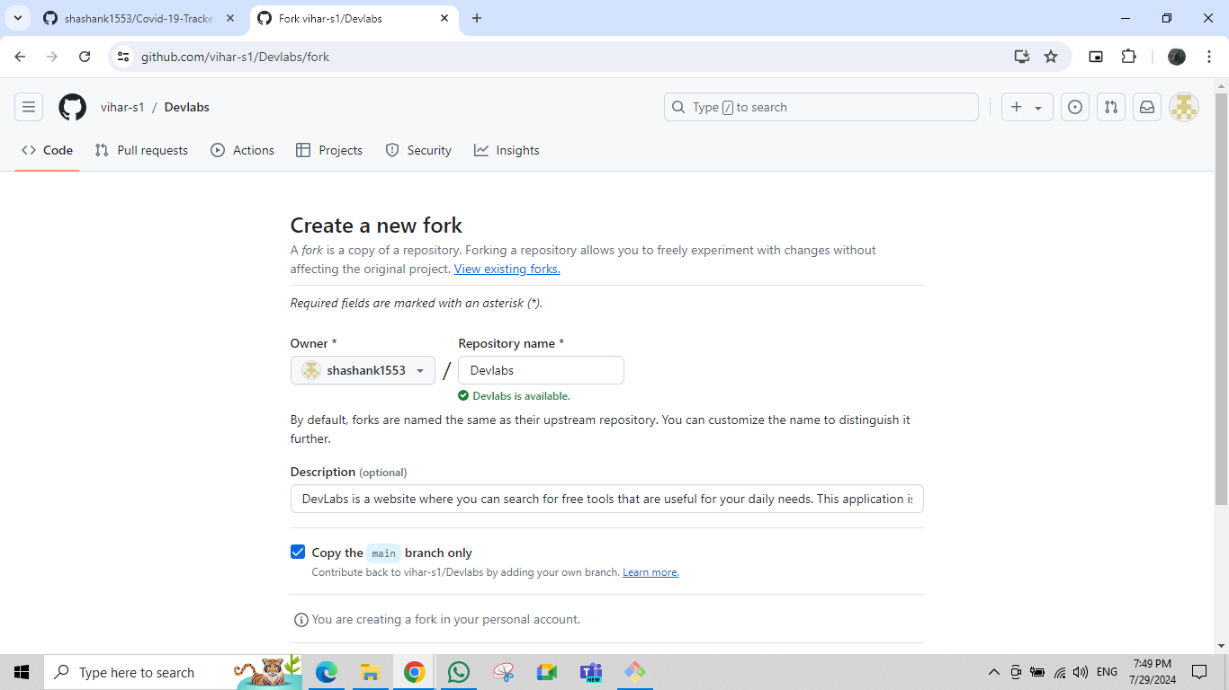git hub🡪git fork

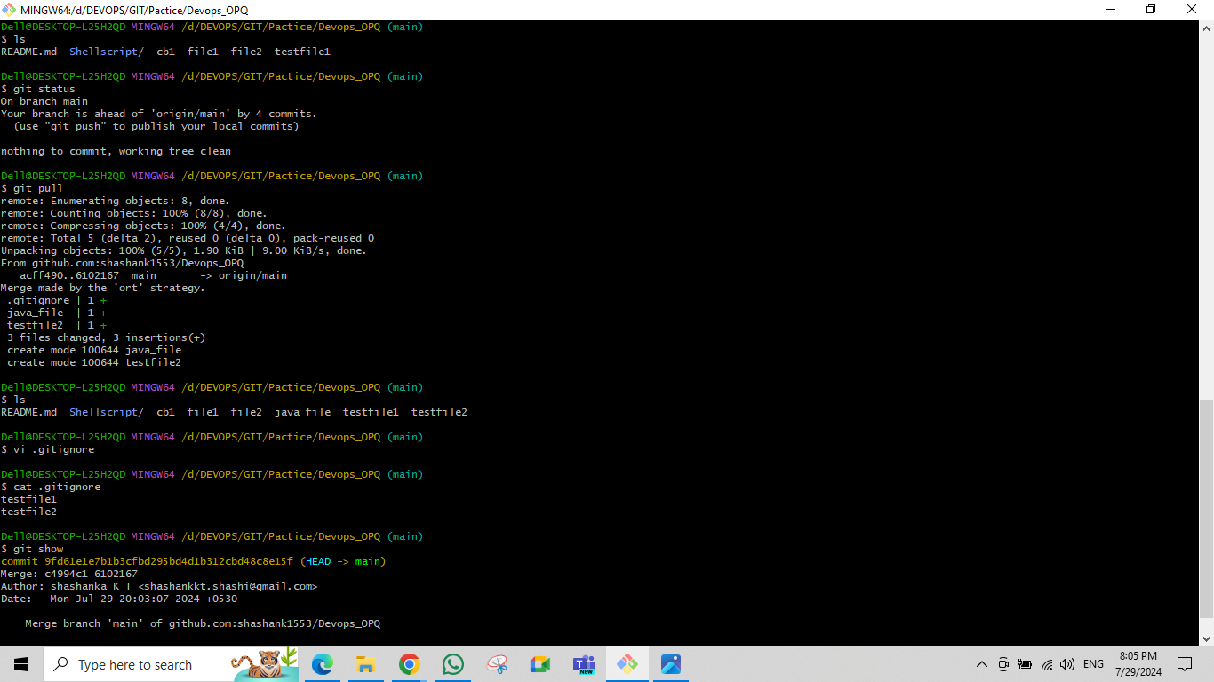.gitignore, git show or git show <commoit ID>,

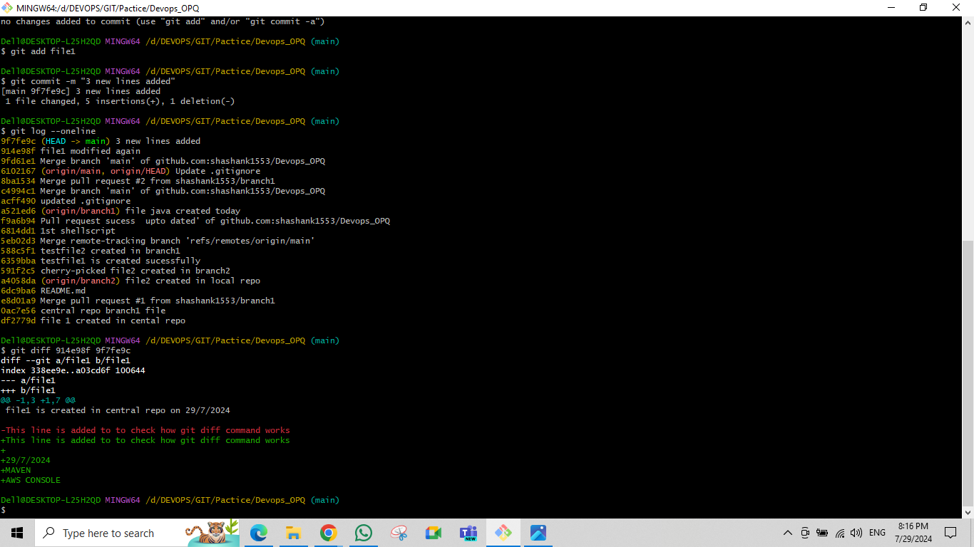git diff <commit-ID-1> <commit-ID-2>

git stash ,git stash pop, git stash drop ,git status

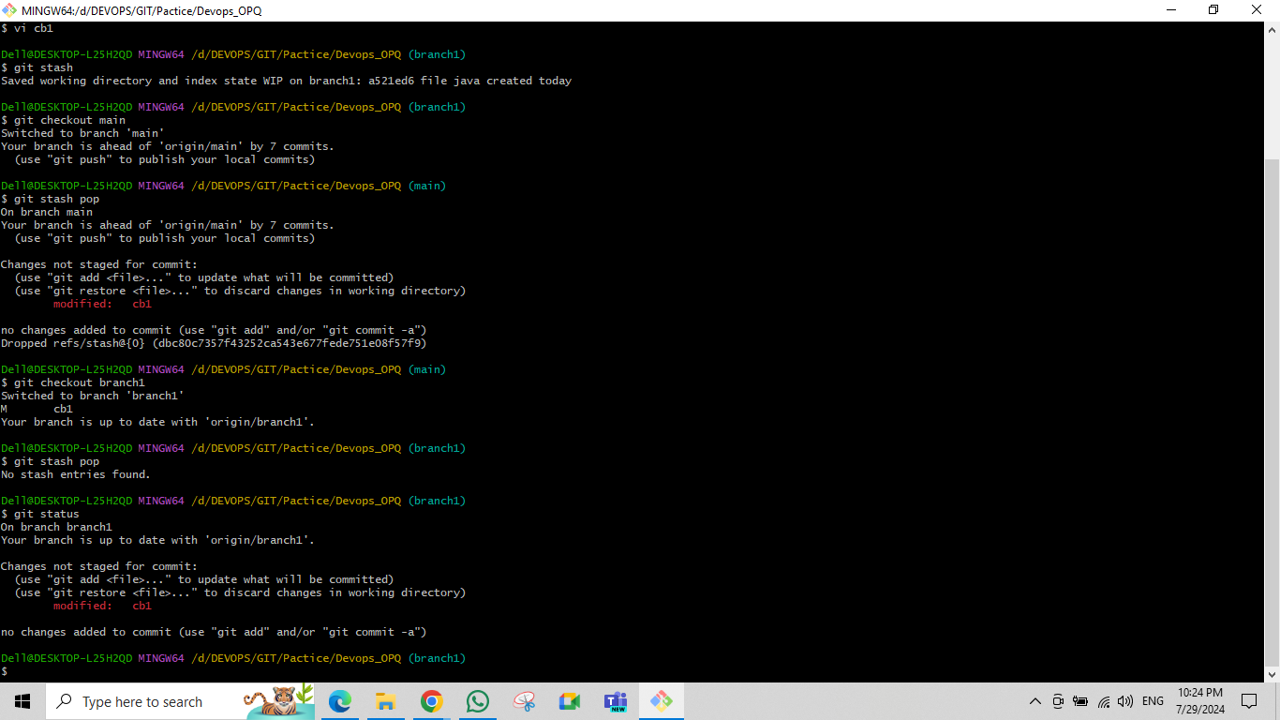

git squash🡪git rebase -i HEAD~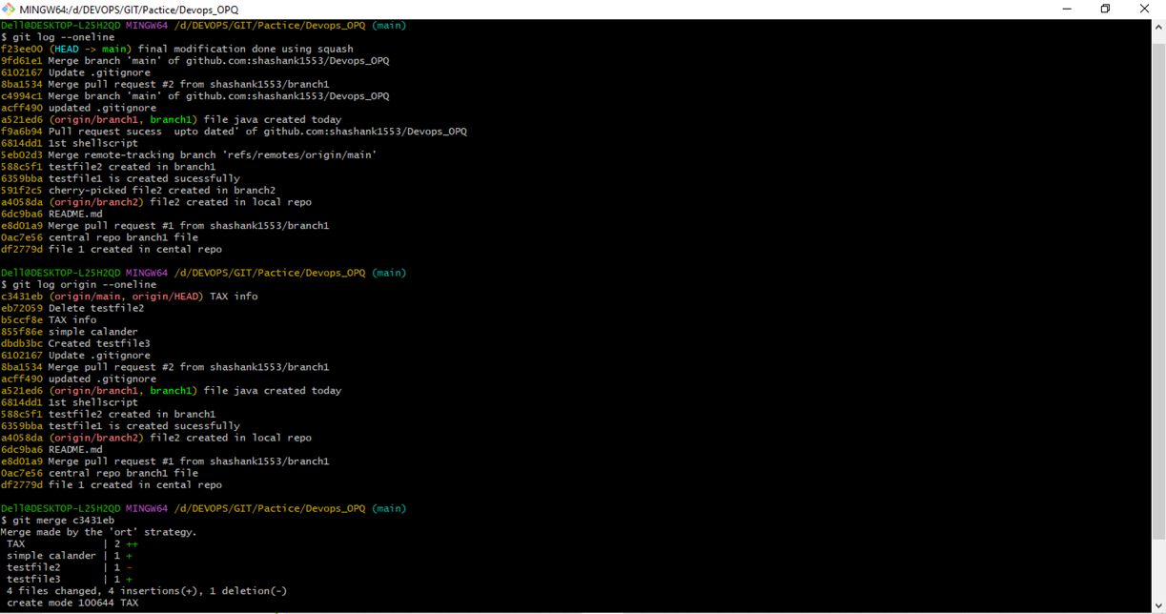4

git squash🡪git rebase -i HEAD~4

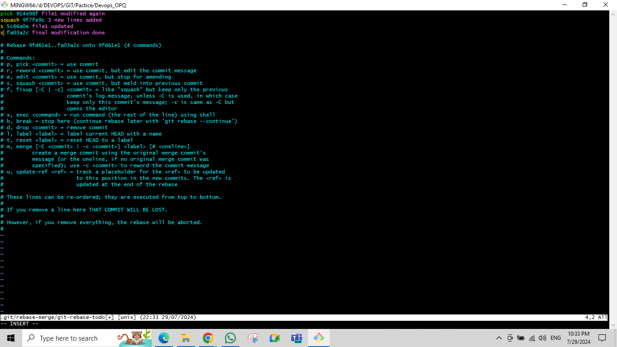

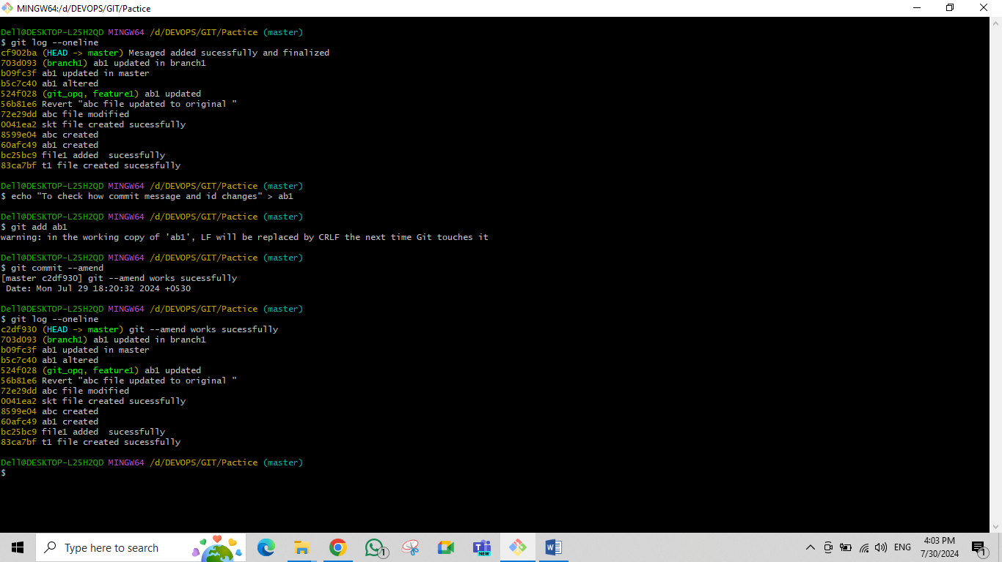git commit –amend

Branching Stratergy

